
Year 12 Physics - Motion and Forces in a
Gravitational Field

Test 1 – Motion Review and Projectile Motion
Name: ANSWER KEY | Teacher: | Score / 45
Comment: |  |  | Time allowed:  50 minutes

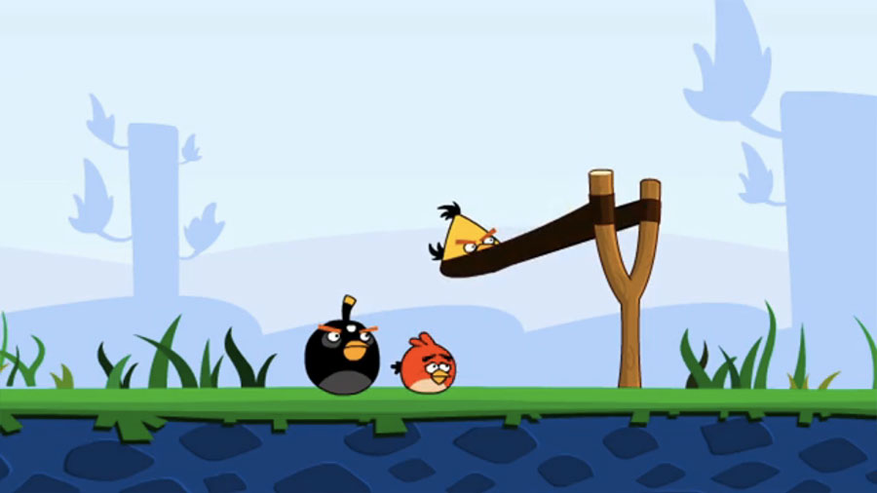

Answer all questions on the paper provided
To achieve full marks, clear, logical working and diagrams MUST be shown.
Answers should be evaluated with an appropriate number of significant figures.

MORE THAN 3 S.F. -1 Mark (Maximum of -2 across paper.)
Section A: Short Answer: 28 marks

- A Battleship simultaneously fires two shells at enemy ships located at different distances as shown below.
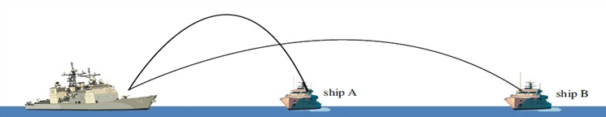

- Which enemy ship gets hit FIRST? (Circle Answer)

Ship A Ship B Both Ships at the same time
(2 Marks)
- Briefly explain your answer to part a

The trajectory (vertical displacement) of the two projectiles indicates that the shell fired at ship A has a higher vertical velocity (1)
As such it will take longer to reach its high point, and then fall back to ship level (1)
(2 marks)

- You throw a 0.100 kg ball up into the air and it reaches a height of 3.25 m above its release point. It then returns to the ground, which is 0.750 m below where it was released. Explaining your logic, calculate the energy lost as it hits the ground.

m = 0.100 kg E_{p} lost = E_{k} gained Logic [1 mark]
s from top = 3.25 + 0.75 mgh = E_{k} gained
= 4.00 m 0.10 x 9.8 x 4.00 = E_{k}
g = 9.8 ms⁻¹ E_{k} = 3.92 J [1 mark]

Logic - When the ball hits the ground this energy is lost
so energy lost = 3.92 J [1 mark]
(3 marks)

- You are doing a movie stunt. You have to leap from one roof to another, 2.50 m away. There is a drop of 50.0 m if you fail (splat!!). You take a long run up and upon a signal from the director you leap over the gap. Draw a free body diagram showing all the forces acting on you at the moment you reach the half-way point. (Stick figure is fine)
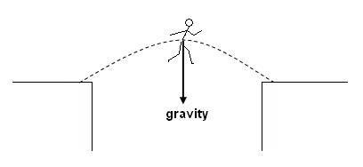

[1 mark arrow, 1 mark label]

If wind resistance is included, this is acceptable. (must be back)
(ANYTHING ELSE = ZERO) (2 marks)
- Mark Weber slows his formula one racing car down from 50.0 ms⁻¹ to a stop in 12.5s as he crosses the line to win the Australian Grand Prix.

- Determine the cars acceleration.

u = 50.0 ms⁻¹ a = v-u
v = 0 t
T = 12.5 s = 0 – 50
12.5
= - 4.00 ms⁻²
= 4.00 ms⁻² in opposite direction to motion (1 Mark Value
1 Mark Direction)

(2 marks)
- Calculate how far from the finish line Webber is when his car comes to a stop
s = ut + ½ at²
s =50 x 12.5 + ½ -4 12.5² -ve acc (1 Mark)
s = 625 – 312.5
s = 313 m from the line (1 Mark Value
1 Mark Direction)

(3 marks)

- Simon was driving home one day when his car broke down... The tow truck had a flat tray which travelled out backwards from the frame of the tow truck and tilted until it was under the front wheels of the car at an angle of 30.0˚ to the horizontal. A tow rope was then attached to the car and a winch pulled the 955 kg car up the tray at a constant velocity.

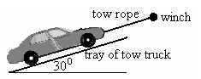
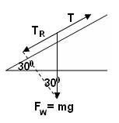
Using a suitable labelled vector diagram to explain your logic, calculate the tension in the rope as it pulled the car up the tray. (1 Mark –
Well drawn Vector Diagram showing components)

T = F sin 30
= (955 x 9.8) sin 30 [1 mark]
T = 4675.5

T = 4.68 x 10³ N [2 marks -1 No units]

(4 marks)
- At a local hockey game, Aimee hits a ball travelling at 14.0 ms-1 north across to Chelsea, who hits it back at 11.0 ms-1 south. If the change in velocity took place in 0.400 s, what was the ball’s acceleration?
u = 14.0 ms⁻¹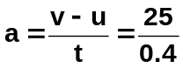 N
v = 11.0 ms⁻¹ S
v – u = 11 S – 14 N
= 11 S + 14 S a = 62.5 ms⁻² South [1 mark answer
= 25 ms⁻¹ S 1 mark direction]
[1 mark] Adding Opposite Vector either in diagram or calculation

(3 marks)

- Aaron throws a small rock horizontally with a velocity of 20.0 ms⁻¹. Given he is standing on the end of a jetty 12 m above the water, how far out from Aaron will the rock hit the water?

s = 12 m s = ut + ½ at² or v² = u² + 2gs
u = 20.0 ms⁻¹ 12 = 0 + 4.9 t² v²= 0 + 2 x 9.8x 12
t² = 12 /4.9 v = 15.3 ms⁻¹
t = 1.56s
t = v – u
a
= 15.3 – 0
9.8
= 1.56 s 2 marks

S_{h} = v_{h} x t
= 20 x 1.56
= 31.2 m 1 mark horizontal calc FT
1 Mark corect answer WITH units

(4 marks)
- The following shows a beach ball thrown a long distance from one person to another without air resistance.

- If there were air resistance, and the two people didn’t move, would the second still catch the beach ball?

YES NO (Circle) (1 mark)

- Draw the expected path of the beach ball with air resistance to justify your answer. 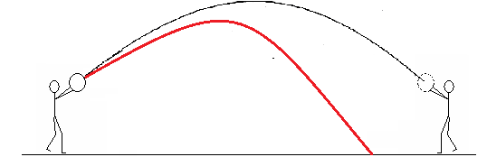 (2 marks)
Trajectory not as High (1)
Trajectory steeper in second half (1)
i.e. Asymmetrical
Section B: Problem Solving: 17 marks

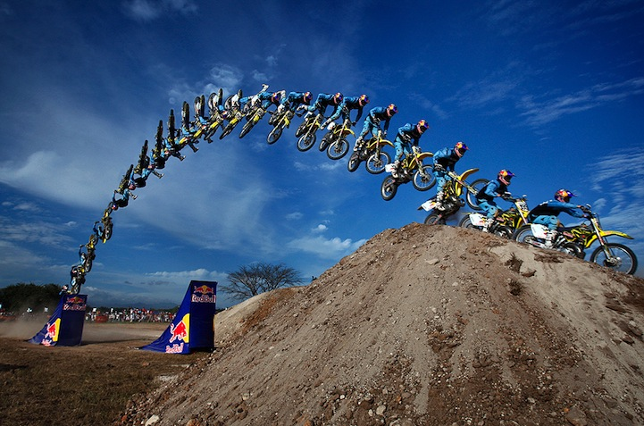
- Charlene is a stunt motor cyclist working on the Red Bull team.

Her major stunt in in a coming show involves her jumping over a 100 m wide gap between a ramp and a hill.

Charlene attempts this by jumping from a 45º ramp at a velocity of 108 kmh⁻¹.

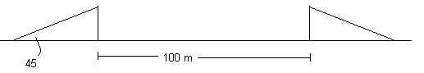

Determine:

  - The horizontal and vertical component of her velocity on leaving the ramp.
V
Vv
Vh
v = 108 kmh⁻¹.
= 30 ms⁻¹

Vv = v sin 45
= 30 sin 45
= 21.2 ms⁻¹ 2 marks
(-1 if velocity not converted or units wrong)

V_{h} = v cos 45
= 30 cos 45
= 21.2 ms⁻¹ 2 marks
(-1 if velocity not converted or units wrong)

(4 marks)

  - Whether Charlene will clear the river at this velocity and angle of projection.
v² = u² + 2gs
v² = - 21.2² + 2 x 9.8x 0 -ve 1 Mark
v_{v} = 21.2 ms⁻¹ 1 mark

NOTE – A good student will know that v = 21.2 ms⁻¹ down without a calculation. To get full marks they should explain / make a statement of the logic used (e.g. “for same starting height/finishing height, the magnitude of the velocity is the same but in opposite direction”. Pay 2 marks WITH logic. 1 without.

t = v – u
a

= 21.2 – (- 21.2) -ve 1 Mark
9.8

= 4.33 s 1 mark

S_{h} = v_{h} x t

= 21.2 x 4.33

= 91.8 m 1 mark

Charlene will fall short of the ramp 1 mark

NOTE - There are other ways to do this calculation. Award marks where method is CLEAR and correctly completed.

(6 marks)

- A second junior member of the Red Bull team is planning an attempt to jump over a series of cars and trucks and land smoothly on the other ramp as shown below. With what speed in kmH⁻¹ must he ride his bike up the ramp if it is angled at 30˚ to the horizontal?
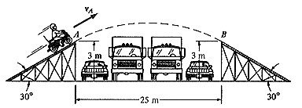

Time in common (both vertical and horizontal)
In horizontal

t=s_{h}/v_{h}
t=25 / vcos30 (1 Mark)

in vertical u_{v} = vsin30 t=25 / vsin30 by subst (1 Mark)

s = ut + ½ at²

0 = (vsin30 x 25 / vcos30) + ½ -9.80 (25 / vcos30)² ^{(-ve signs used correctly )} (1 Mark)

0 = tan30 x 25 + ½ -9.80 (25² / v² (cos 30)² → v’s cancel out

0 = 14.4337 (-4.9 x 625) / (v² x 0.75)

- 14.4337= - 4083.33 / v²

v² = 282.9

v = 16.81ms⁻¹ (3 Marks) (-1 for small errors)

v = 60.6 kmH-¹ (1 Mark)
Pay correct conversion of incorrect answer

(7 marks)

End of test - More space over if required

